**Ms. Savitha Dsouza**

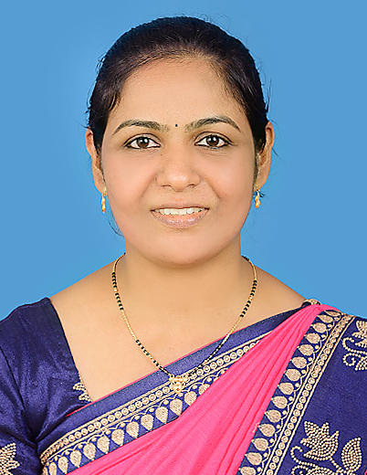

**MSW (HRD), M.A, KSET, B.S.W, Ph.D. Scholar**

**E-mail id: savitha_dsouza@staloysius.edu.in**

**Contact number: 919483623216, 9481635165**

|  |
| --- |
|  |

**Career objective:**

To be considered for a suitable post where my qualification, creativity, ability and hard work would be recognized as the most valuable assets and which in turn would result in the symbolic growth of the organization and self.

**Educational summary**

|  |  |  |  |  |
| --- | --- | --- | --- | --- |
| **COURSE** | **NAME OF INSTITUTE** | **UNIVERSITY / BOARD** | **YEAR** | **%** |
| **MSW (HRD)** | **ST ALOYSIUS COLLEGE (AUTONOMOUS) MANGALORE** | **MANGALORE UNIVERSITY** | **2012**  **to**  **2014** | **I sem - 68%**  **II sem - 74%**  **III sem - 73%**  **IV sem - 76% IInd Rank** |
| **MA(SOCIOLOGY)** | **IGNOU** | **DELHI UNIVERSITY** | **2021-2023** | **70%** |
| **B.S.W** | **ST. JOSEPH’S COLLEGE**  **(AUTONOMOUS)**  **BANGALORE** | **BANGALORE UNIVERSITY** | **2008**  **to**  **2011** | **I Sem – 72%**  **II Sem – 69%**  **III Sem - 71%**  **IV Sem - 72%**  **V Sem – 70%**  **VI Sem – 74%** |
| **PUC** | **JYOTHI NIVAS PU COLLEGE**  **BANGALORE** | **KARNATAKA** | **2002**  **to**  **2003** | **56%** |
| **S.S.L.C** | **VITTAL GIRLS HIGH SCHOOL**  **VITTAL** | **KARNATAKA** | **2007** | **52%** |

**Professional Experience:**

Pursuing Ph.D. from Mangalore University.

Presently working at St Aloysius(Deemed to be University) Mangaluru from September 2020 as Assistant Professor in the Department of UG Social Work and Sociology.

Worked as a Part time Lecturer at St Aloysius College (Autonomous) Mangalore and City Hospital Nursing College Mangalore for Sociology Subject and Foundation course from 2019.

Worked with PVR Cinemas, Mangalore as an Admin and HR Manager from April 2016 to September 2016.

Previously worked with Jubilant Food works, Dominos Pizzas regional office Mumbai as HR Assistant for Six months.

**Job Profile**

* Proficiency in teaching -Sociology and Social work.
* HR Administration & Generalist activities-PF, ESIC, PAYROLL etc.
* Recruitment, Interview and Selection of candidates.
* Handling joining & Exiting of candidates.
* Maintaining Leave & attendance records of the candidates.
* Maintaining punching records through software.
* Preparing offer letter, Appointment letter, experience letter and relieving letter.
* Maintaining employees ESIC & EPF records.
* Handling daily, weekly and monthly follow up and correspondence.

**Computer proficiency**

* Skilled and experienced in computer applications.
* MS office applications. (MS Word, MS Excel, MS PowerPoint, Tally, HTML, DOS)
* Software Packages: MS-Office & Internet Concept

**Research study**

A study on Psycho-social problems faced by girls trafficked for commercial sex work.

**Field work practicum / placements:**

* Internship in Jubilant Food works Ltd Regional Office, Domino’s Pizza, Mumbai.
* Worked as Recruiter, Held interview and selection of Employees, F&F settlement, payroll administration, Training, PF, and ESI and so on.
* Field work practicum at **KIOCL (Kudremukh Iron Ore Company Ltd), Panambur, Mangalore, For the academic year 2013-2014**
* Training obtained on Pay roll administration, leave and holiday administration, E.S.I and P.F, labor welfare administration, Filing important documents and various trainings held on labor law.
* **Field work experience at Sanjeevini, Kinnigoli, Mangalore for the academic year 2012-2013**
* Exposure to social work methods and social welfare of the people.
* Conducted women’s day celebration.
* Attended SHG meetings and held programmes and games for women and children

**Achievements**

* MC for National Seminar held in the College.
* MC for various programmes conducted in Parish level and for local community functions.
* Active N.S.S and CSA volunteer at St. Joseph’s College, Bangalore.
* Been class representative while perceiving degree studies.

**Seminars and Workshops**:

* Organised National level seminar Metanoia-2023 on ‘Hands that do the unthinkable: Manuel scavengers’.
* Organised National level Seminar Metanoia-2022 on the topic, ‘Towards the Cis tide: across Transgender community’.
* Organized webinars and participated in many webinars and certificate courses.
* Actively participated in the national conference ‘SAMPRATHI’ held at St Aloysius College, Mangalore in the year 2012 and 2013.
* Attended workshop on ‘HUMAN RESOURCE- GAME CHANGERS’ held at St Aloysius College, Mangalore in the year 2013.
* Been volunteer for ‘BALA MELA’ (A day of festivity for the less privileged children’ organized by ECHO and eighty likeminded organizations.
* Been part of rescuing young girls who are trafficked for commercial sex work in partnership with NGO at Bangalore.
* Participated in the exhibition on ‘EMERGING INDIA’ held at St. Joseph’s College, Bangalore.

**Competencies / skills:**

* Social , Good leadership qualities
* Communication, Rapport Building
* Decision making, Elegant team player
* Adaptable, Event manager

**Hobbies:**

* Singing, reading, listening to music, making art and craft, Stitching.

**Personal details**:

Name: Savitha D Souza

D.O.B: 30 March 1985

Nationality: Indian

Marital status: Married

Languages known: Kannada, English, Hindi, Tulu, and Konkani

Permanent address: ‘Sacred Nest’, Kurumbil house, Guttakadu Road,

Kinnigoli, 574150.

**Declaration:** I hereby declare that the information furnished above is true to the best of my knowledge and belief.

Place: Kinnigoli Savitha D’Souza Date: 28.03.2025

Signature

**References:**

Mr. Murgesh Dr. Rose Veera D souza

Deputy Manager (HR & Admin) Professor, HOD and Dean

KIOCL Limited St Aloysius (Deemed to be

Panambur University)

Mangalore-575010 Mangalore- 575003

Contact No. +91 9535020225 Ph. No. 9448026838

E-mail: [murgeshs1981@gmail.com](mailto:murgeshs1981@gmail.com)