JOEL P JOSEPH

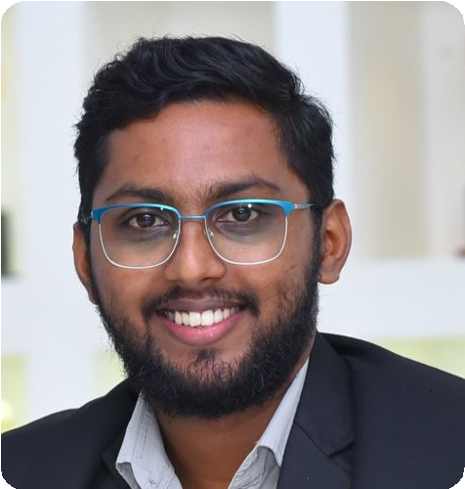

 **JOEL P JOSEPH**

 **Mangalore** ** 8086534134**

 [**joel.p.j.k@gmail.com**](mailto:joel.p.j.k@gmail.com)

**Food Science Technician & Nutritionist**

**Total Experience: 5+ Years**

# <https://www.linkedin.com/in/joel-joseph-320318113/>

# PROFILE • ABOUT ME

Results-driven **Food Science Professional, Nutritionist** and dynamic leader with a successful track record in both **individualized patient care** and strategic departmental leadership. **Over 4 years of experience as a Dietitian**, coupled with a proven ability to guide and elevate teams as the **Head of the Department of Food Science and Nutrition**.

As a **Food Science Technician**, I am dedicated to ensuring the **safety and quality of food products** through **meticulous analysis and testing**. With a strong background in **food science, laboratory procedures, and quality control standards**, I am committed to upholding the **highest standards of food safety and regulatory compliance**.

# WORK EXPERIENCE

**Assistant Professor – Department of PG studies and Research in Food Science**



**St. Aloysius (Deemed to be University), Mangalore** June 2024 -

**HEAD OF DEPARTMENT - FOOD SCIENCE AND NUTRITION**

**YENEPOYA(DEEMED TO BE UNIVERSITY)** Nov 2020

**Karnataka, India**  -Dec 2023

**DIETITIAN**

**LA BELLE BODY CARE**

**Karnataka, India**

**FIELD DIETITIAN**

**BRITISH BIOLOGICALS**

**Kerala, India**

# DUTIES &RESPONSIBILITIES

## As Department Head, Nutritionist &Dietitian

Oct 2019

- Oct 2020

Jul 2018

- Mar 2019

Assess nutritional needs, diet restrictions and current health plans to develop

and implement dietary-care plans and provide nutritional counseling. Consult with physicians and health care personnel to determine nutritional needs and diet restrictions of patient or client.

Advise patients and their families on nutritional principles, dietary plans and diet modifications, and food selection and preparation.

# EDUCATION

**Food Science and Nutrition, Master of Science Mangalore University**



Karnataka, India

Post Graduate May 2018

**Microbiology Bachelor of Science**

**Kannur University**

Kerala, India

Graduated May 2016

**Intermediate**

**Government of Kerala Board of Higher Secondary Examination**

Kerala, India

Completed May 2011

# TRAINING &

**CERTIFICATIONS**

**Health Research Fundamentals**

**ICMR, National Institute of Epidemiology** **(India) Chennai, 2023**

**Academic and Research Report Writing**

**NITTR Kolkatta** **(India)** 2023

 **SOFT KILLS**

## Bilingual Communication Decision Making Attention to Detail

**Time Management Planning & Organizing**

## Critical & Creative Thinking Leadership & Team Management

**Adaptability & Multi Tasking**

Counsel individuals and groups on basic rules of good nutrition, healthy eating habits, and nutrition monitoring to improve their quality of life.

Monitor food service operations to ensure conformance to nutritional, safety, sanitation and quality standards.

Coordinate recipe development and standardization and develop new menus for independent food service operations.

Develop policies for food service or nutritional programs to assist in health promotion and disease control.

Inspect meals served for conformance to prescribed diets and standards of palatability and appearance.

Develop curriculum and prepare manuals, visual aids, course outlines, and other materials used in teaching.

Prepare and administer budgets for food, equipment and supplies. Purchase food in accordance with health and safety codes.

Select, train and supervise workers who plan, prepare and serve meals. Manage quantity food service departments or clinical and community nutrition services.

Coordinate diet counseling services.

Organize, develop, analyze, test, and prepare special meals such as low-fat, low-cholesterol and chemical-free meals.

Plan, conduct, and evaluate dietary, nutritional, and epidemiological research. Plan and conduct training programs in dietetics, nutrition, and institutional management and administration for medical students, health-care personnel and the general public.

Make recommendations regarding public policy, such as nutrition labeling, food fortification, and nutrition standards for school programs.

Write research reports and other publications to document and communicate research findings.

Confer with design, building, and equipment personnel to plan for construction and remodeling of food service units.

# CAREER HIGHLIGHTS

Nutrition program development and implementation Nutrition counseling and education

Nutrition assessment and screening Corporate wellness program management Nutrition seminar creation and facilitation Nutrition database management Individualized nutrition plan development Healthy eating habit education

Research and implementation of nutrition trends and best practices Collaboration with healthcare professionals

Patient satisfaction improvement Chronic condition management Childhood obesity prevention

Employee engagement and productivity improvement

# COMPUTER PROFICIENCY

**Windows**

**MS Office**

**Basic Computer Operations**

 **ACADEMIC PROJECTS COMPLETED**

**Evaluation of free formaldehyde and volatile bases formation in selected species of fishes during ice storage. – ICAR CIFT, Kochin**

# LANGUAGES

**English**

**Hindi**

**Malayalam**

**PERSONAL**

**Kannada**

# INFORMATION

## Birthday

18/03/1994

## Gender

Male

**Marital Status** Married **Nationality Indian**

# NOTABLE ACHIEVEMENTS

Worked as Deputy Chief Superintendent of Examination – Yenepoya (Deemed to be University)

Worked as Observer of Examination – Yenepoya (Deemed to be University) Worked as Custodian of Examination – Yenepoya (Deemed to be University) Worked as Program Officer NSS – Yenepoya (Deemed to be University) Working as College Council Member – Yenepoya (Deemed to be University) Participated in seminar on Food Safety by Dhaya Food Safety

Participated in National seminar held by Nutritional Society at St. Johns Research Institute , Bangalore

Successfully did a Minor Research Project in ICAR Central Institute of Fisheries Technology Cochin , Ernakulum

# DECLARATION

I, hereby declare that the information contained herein is true and correct to the best of my knowledge and belief.

**JOEL P JOSEPH Mangalore**